**KABOJJA JUNIOR SCHOOL**

**P.1 LITERACY 1 MID – TERM EXAMS I, 2024**

**Time Allowed: 2hrs 30 minutes**

**NAME**: ……………………………………………………………………………………………………………………….

**DISTRICT:** …………………………………………………… **CLASS:** ……………………………………….

1. A ________________is a place where people go to learn. (school, home)

2. **Draw these people found at school**.

teacher cook

cleaner headteacher

gatekeeper

3. We use a ____________________for sweeping.

4. **Circle the activities done at school**.

sweeping crying writing eating reading

singing

5. **Match correctly.**

driver

cook

cleaner

teacher

7. What is the name of your teacher_______________(tr. feibe, tr.shafic)

8. **Fill in the missing sound.**

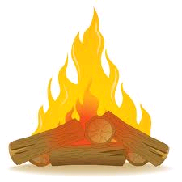 t___ble, cha___r, c___p, br___m, pl___te

9. **Name these dangerous objects**.

_______________ ________________

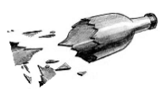

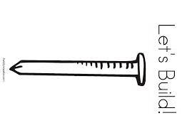 _____________ _______________

broken bottle, nail, fire, pin

10. A place where people stay is a ______________(school, home)

11. **Name these people found at home**.

 _______________ _________________



_______________ ___________

brother, father, mother, sister

12. **Match correctly.**

father fetches water

mother mops the house

sister heads the family

brother cooks food at home

13. What is the name of your classteacher____________(tr .mary,tr. mary)

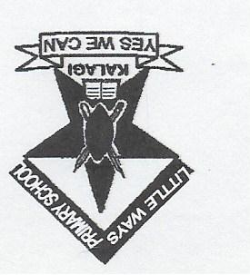14. **Name these school symbols**.

_____________ ____________

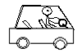

________________ LITTLEWAYS INFANT _______________

AND PRI.SCHOOL

school bus, badge, uniform, flag

15. **Draw your school.**

16. **Name these foods we eat**.

 ____________ ____________

__________ ________________

maize, cassava, apple, pineapple

17. **Tick the building found at school**.

classroom, house, office, bedroom, dormitory, kitchen